**Earthquakes, Volcanoes, and Plate Tectonics:**

**Introduction:**

In this assignment, we are going to learn that how volcanos, earthquakes affect the landforms. The patterns all over the world, the destruction, migration etc. The level of earthquake affects the size of population, resources, lives, etc. How magnitude & frequency are related in terms of earthquake. The components which make magma inside the lava, reasons of volcanic eruptions, research on Rings of Fire (Interesting Part). The reasons how subduction zones, cross sections are created on the earth surface. Research on the Patterns of Plate Boundary affecting the earth surface.

**Data:**

**Methods:**

**Analysis:**

1. Ques here

* **Kermadec Islands region** was the place where the latest earthquake taken place.

1. Ques here

* **Pass**

1. **Ques here**

* 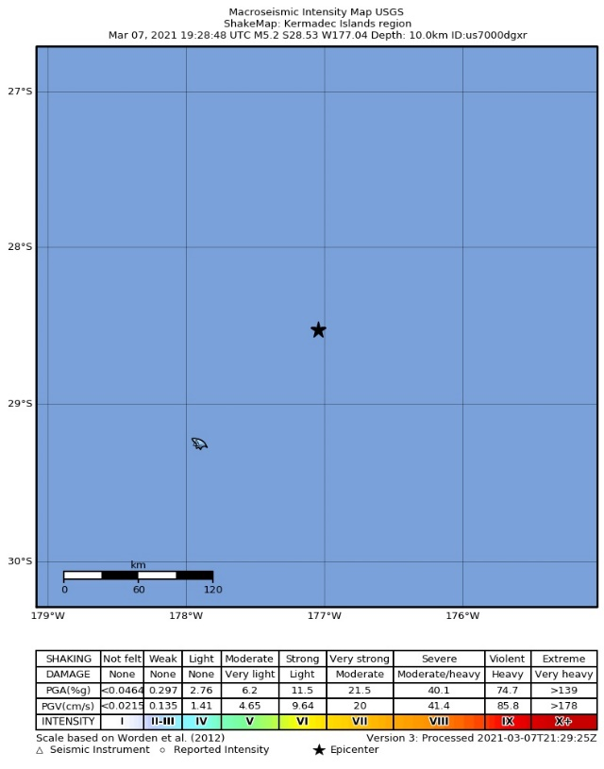3rd MMI rate in **Kermadec Islands region**.

Figure .2

Figure 1.2

1. **Ques here**

* The **Magnitude** of this earthquake was **M 5.2**

1. **Ques here**

* There are 0 responses recorded for this earthquake till now (**3/7/2021**).

1. **Ques here**

* The estimated deaths in 2019 are 244.

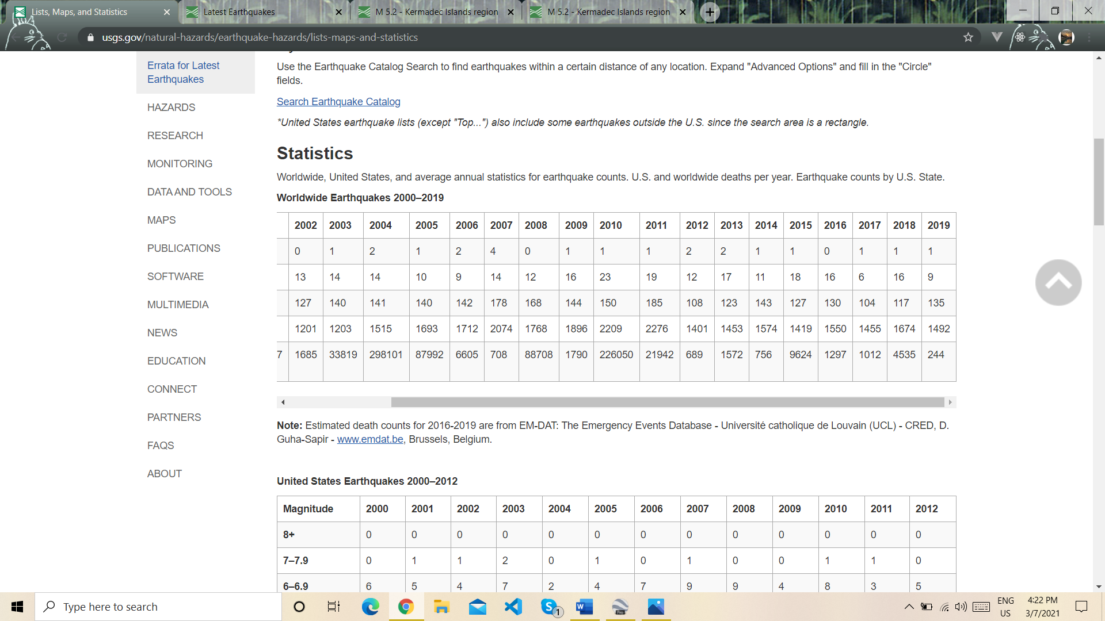

Figure 1.3

1. **Ques here**

* The estimated deaths in 2019 was **244** & in 2010 it is **226050 (fig. 1.3)**. So, there’s a big difference in both of them. The earthquakes were very active in that time as it led so many deaths all over the world & if we compare it with the **2019** **Data** it’s a big down fall due to less active earthquakes.

1. **Ques here**

* There were so many earthquakes in 2010 with high magnitude that destroyed many countries & numbers of people were dead.
* The most affected country was **Haiti** in which more than 200,000 people lost their family, friends, homes, etc. As, Haiti was not a very rich country from starting, **“There was nothing taken from nothing & now, they left out with even less they had before.”**
* There were also some other countries like U.S.A, Mexico, New Zealand affected by the earthquake at that time.

|  |  |  |  |  |
| --- | --- | --- | --- | --- |
| Country | Magnitude | Date | Depth (miles) | No. of Deaths |
| Haiti | **7.0** | **January 12, 2010** | **8.1** | **100,000 – 315,000** |
| U.S | **6.5** | **January 10, 2010** | **13.5** | **50** |
| Chile | **8.8** | **February 27, 2010** | **14.2** | **525** |
| Mexico | **6.2** | **April 4, 2010** | **6.2** | **10** |

1. **Ques here**

* There were **9 Earthquakes** in **Alabama** in **Year 2015**.
* The highest magnitude was 3.5 M.
* The lowest magnitude was 2.6 M.

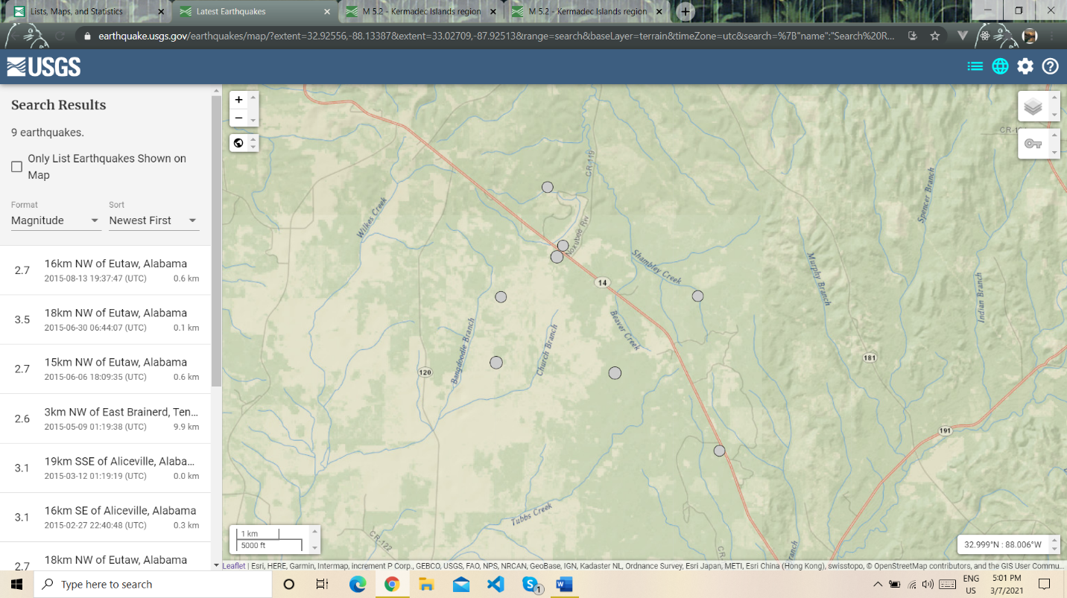

Figure 1.4

1. **Ques here**

* There were **1459 Earthquakes** in **Alaska** in **Year 2015**.
* The highest magnitude was 6.8 M.
* The lowest magnitude was 2.5 M.

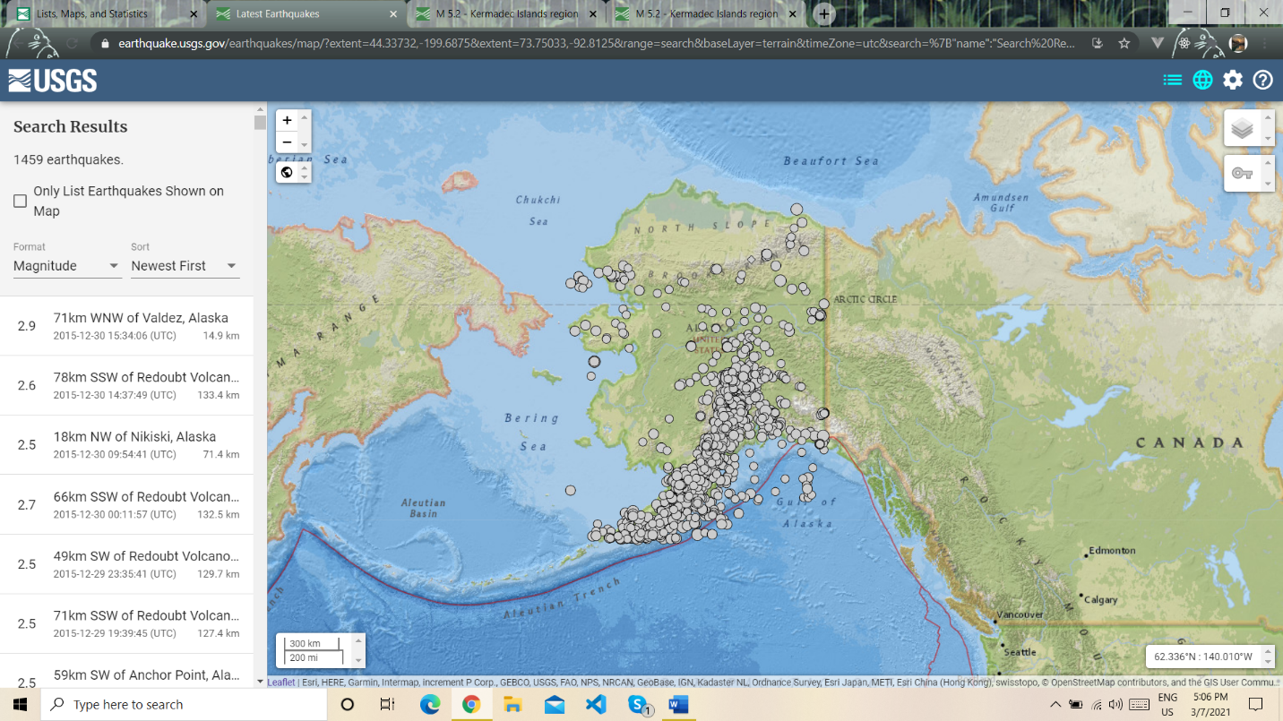

Figure 1.5

1. **Ques here**

* **Pass story of Eliza**

1. **Ques here**

* As the earthquake started at rate of 3 & goes up to 10. I can see that the **Bay Area** is most affected in comparison to others. Due to earthquake, it creates a pattern of straight line on the side of bay area (Cracks), started at low intensity.

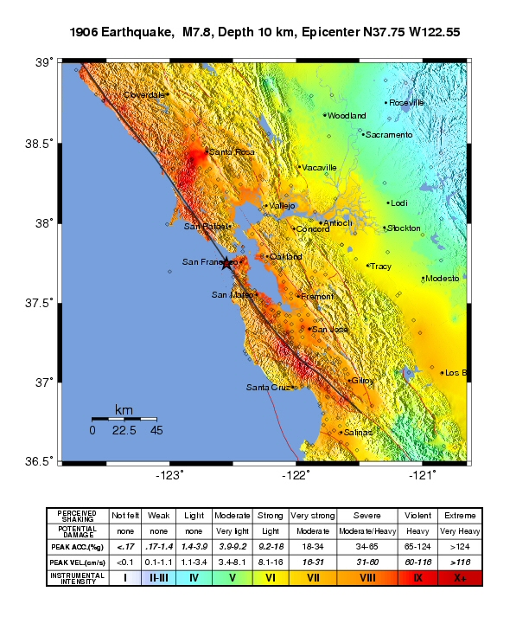

Figure 1.6

1. **Ques here**

* The relationship between Magnitude & the Frequency is **“Higher the Magnitude, Lower Frequency.”**
* Example: Magnitude: 7 & Frequency: 10 per year.
* Magnitude: 3 & Frequency: 100,000 per year.

**Paste here python-based graph**

1. Ques here

* Pass

1. **Ques here**

* The **Ring of Fire** is the most extensive zone on the earth, hundreds of volcanos line the shore of the Pacific Ocean. And, form an ARC which extends 25,000 miles from South America along America’s Northwest Coast then Russia, japan, New Zealand, Southeast Asia. The investigations begin in the Alaska because the **75% of volcanos eruption** in USA are in **Alaska**. So, this is the perfect laboratory for the volcanologists. The ring of fire lavas is rich in SILICA, which make them less able to flow, creating tall volcanos. The thickness of these lava’s makes them Lethal. Due to the rich Silica in the lava the pressure in the volcano increases & after a certain time period when it’s more than enough to hold it just burst with high dangerous gases, chemicals the result is giant explosion.

The scientist found the HORNBLEND into the lava which is the proof of the water presence into deep down the earth. Basically, which is the one of essential component of lava inside the earth. Due to water the rocks melts into the magma & sours up to the surface, making giant explosion at the surface.

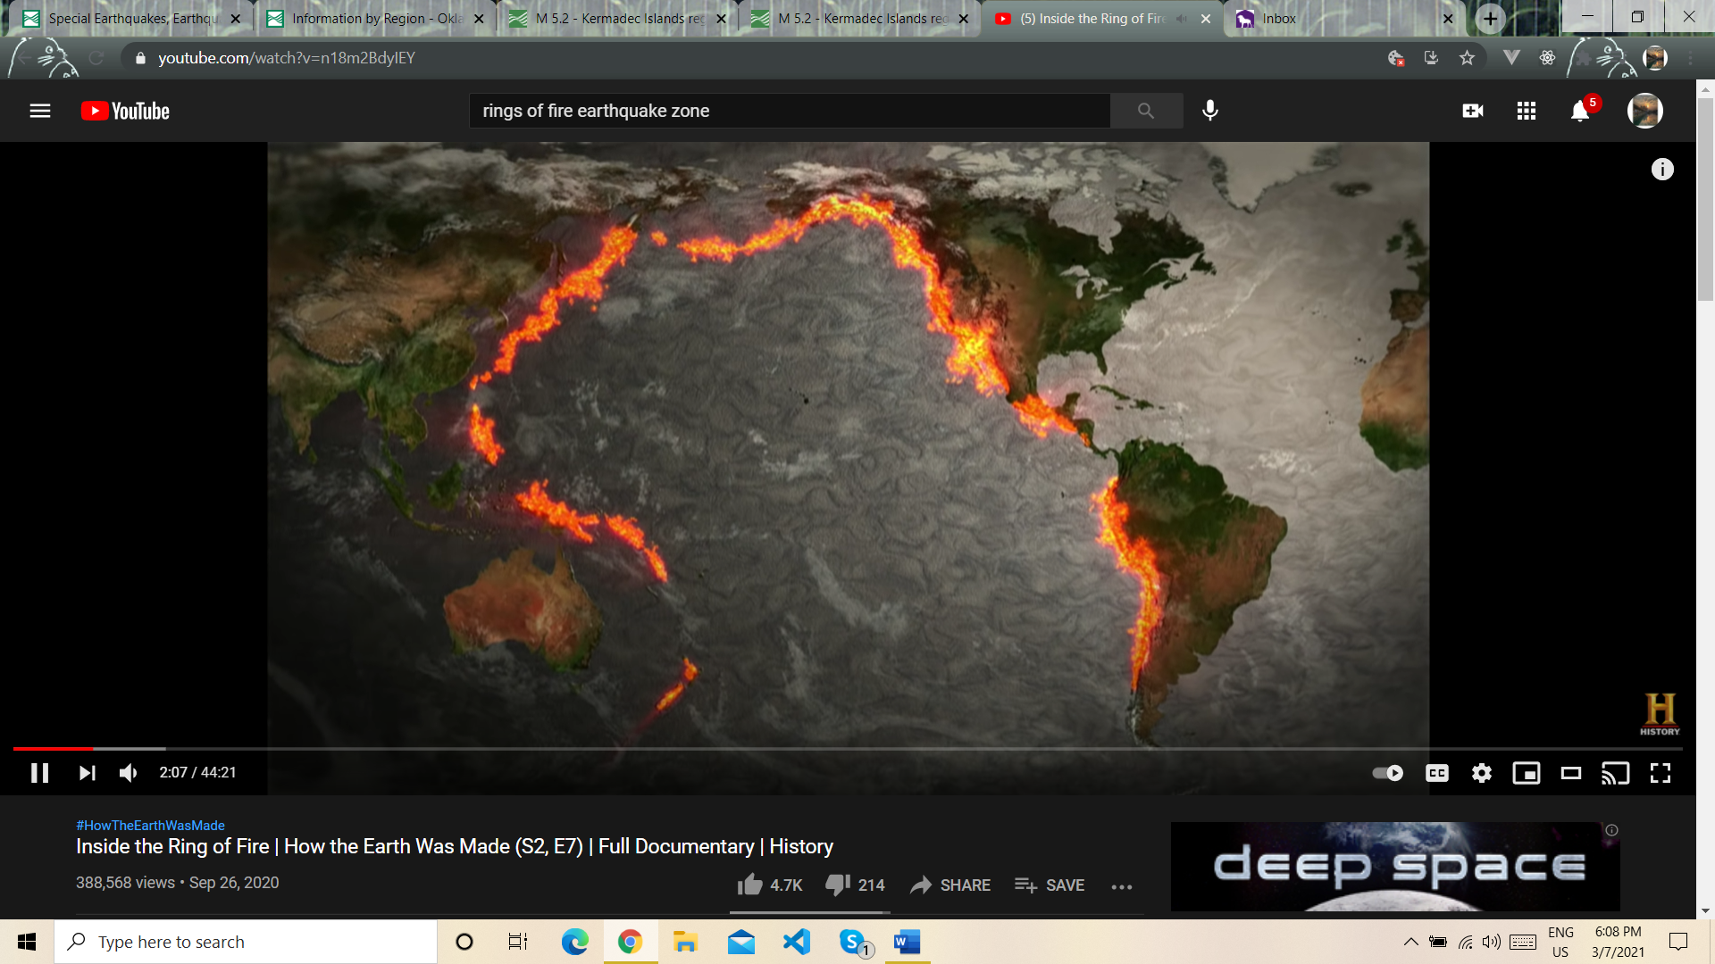

Rings of Fire

1. **Ques here**

* **Pass**

1. **Ques here**